

College of Engineering

Mini Project Proposal

Annoying Dorrbell

Authored By

Conan Poppe 822196980

Cody Allen 820546305

Surendra Mahadi 822948887

Ghozlan Fagerah 820906691

Lucas Adams 820308457

Ahmad Alawadhi 822050483

For: Professor Dorr

EE 496

Sep 6th,2020

To: Professor Dorr

From: Conan Poppe 822196980, Student 2, …

Subject: Mini-Project Proposal – EE-496A

Date: Sep 6, 2020

**Summary**

We propose to build a circuit that will produce the classic, and annoying, ding-dong sound of a doorbell. The title of our project is “Annoying Dorrbell.” This project will be done to satisfy the Mini-Project

requirement of EE 496A.

**Project Description and Block Diagram**

A block diagram for the circuit is shown in Figure 1. In this Annoying Dorrbell Circuit, we have used two separate 555 Timer ICs to generate an easily recognizable signal. In first 555 Timer IC, we have connected a 1k (R1) resistor between Vcc & the 7th pin of a 555 Timer (U1). And a 10k (R4) resistor & 50k Pot (RV1) between pin 7 and 6. Pin 2 is shorted with pin 6 and a 100uf (C1) capacitor is connected to pin 2 or 6 with respect to ground. A 10nF (C2) capacitor is also connected to pin 5 of U1 with respect to ground. Pin 1 is connected to ground and pin 4 and 8 connected to Vcc. The output pin, pin 3, of the first 555 timer is connected to pin number 5 of the second 555 Timer (U2) through a 330 ohm resistor (R4).

In Second 555 Timer IC, Pin 4 and 8 are connected to Vcc and 1 to GND. A 100nf (C3) capacitor is connected to pin 2 or 6 with respect to ground. A 1k resistor (R3) is also connected between Vcc and 7th of U2. And another 50K Pot (RV2) is connected between pin 7th and 6th. A speaker is connected to pin 3 of U2 through 100uF (C4) capacitor with respect to ground.

A 100uf (C5) capacitor is also connected between Vcc and ground. Finally, we have connected a 9v Battery to power the circuit.

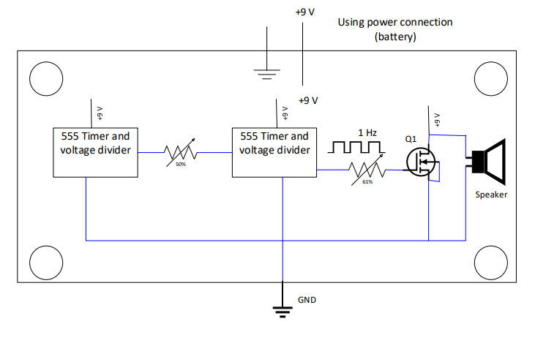

The circuit will be constructed on a Printed Circuit Board (PCB) with approximate dimensions [INSERT KiCAD DIMENSIONS]. Mounting holes will be located at the corners of the board, 0.25” from each edge. The mounting holes will be connected to ground and have clearance for a number 6 screw. Surface-mount components will be used.

**Specifications and Validation**

|  |  |  |
| --- | --- | --- |
| ID | Specification | Validation |
| 1 | The circuit shall operate from a power supply 9V battery. | Circuit must pass all tests using only the 9V battery. |
| 2 | There will be two distinct tones produced. | Verify that two distinct sounds can be heard when the circuit is powered on. |
| 3 | The tones produced will be at least 140 Db in volume | Measure the Db output of the tones when the circuit is powered on. |
| 4 | The tones produced will be at least 200 Hz difference. | Frequency output from each IC will be measured. |
| 5 | The tones of the bell can be adjusted at will. | While the circuit is powered on, adjust the tones using RV1 and 2. |

**Satisfaction of Course Requirements**

|  |  |
| --- | --- |
| Requirement | How Met |
| Must be completed in groups. | Our group consists of six students |
| The design must be tested as specified in the previous section | When the circuit is powered on, all tests are completed in sequence. |
| Must have at least one digital IC | The circuit has two 555 Timer ICs |
| Must have at least one analog component | The circuit has a MOSFET and a speaker. |
| The project should have a simple function. | The circuit simply makes two sounds. |
| Parts budget must not exceed $15.00 | The full cost of the circuit is $9.67 |
| Must have four mounting holes in a rectangle. | Mounting holes will be located at the corners of the board, 0.25” from each edge. |

**Team Skill Assesment**

|  |  |
| --- | --- |
| Skill or System Component | Implementation |
| 555 Timer Design | Astable mode 555 Timer operation is covered in many application notes and datasheets. |
| Schematic Capture | Team members will learn KiCad. |
| PCB Design | Team members will learn KiCad. |
| Block Diagram Design | Team members will learn Vizio. |
| PCB Fabrication | SDSU Milling facility used. |
| Install components on PCB | Done as part of several EE course labs |
| Debug and Troubleshooting | Members gained experience in EE430 |

**Cost**

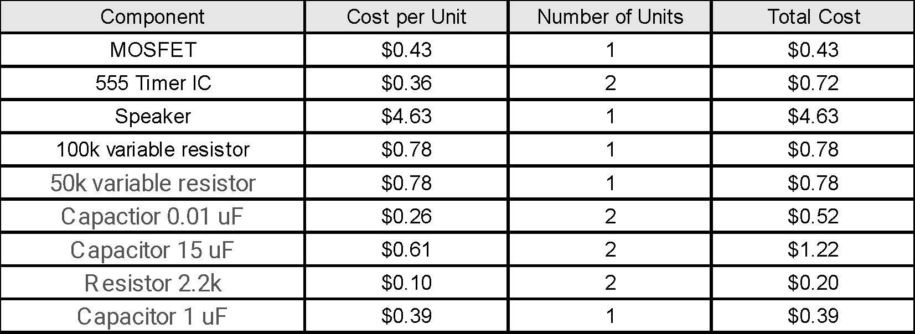

**Customer Sign-off Sheet**

**Team Members:** Conan Poppe, Cody Allen, Surendra Mahadi, Ghozlan Fagerah,

Lucas Adams, Ahmad Alawadhi

**Project Title:** Annoying Dorrbell

**Satisfaction of Technical Requirements**

|  |  |  |  |
| --- | --- | --- | --- |
| ID | Specification | Validation | Intial |
| 1 | The circuit shall operate from a power supply 9V battery. | Circuit must pass all tests using only the 9V battery. |  |
| 2 | There will be two distinct tones produced. | Verify that two distinct sounds can be heard when the circuit is powered on. |  |
| 3 | The tones produced will be at least 140 Db in volume | Measure the Db output of the tones when the circuit is powered on. |  |
| 4 | The tones produced will be at least 200 Hz difference. | Frequency output from each IC will be measured. |  |
| 5 | The tones of the bell can be adjusted at will. | While the circuit is powered on, adjust the tones using RV1 and 2. |  |

**Satisfaction of Course Requirements**

|  |  |  |
| --- | --- | --- |
| Requirement | How Met | Initial |
| Must be completed in groups. | Our group consists of six students |  |
| The design must be tested as specified in the previous section | When the circuit is powered on, all tests are completed in sequence. |  |
| Must have at least one digital IC | The circuit has two 555 Timer ICs |  |
| Must have at least one analog component | The circuit has a MOSFET and a speaker. |  |
| The project should have a simple function. | The circuit simply makes two sounds. |  |
| Parts budget must not exceed $15.00 | The full cost of the circuit is $9.67 |  |
| Must have four mounting holes in a rectangle. | Mounting holes will be located at the corners of the board, 0.25” from each edge. |  |

